Exp.No-6
6. Write a C program for ciphertext has been generated with an affine cipher. The most frequent letter of the ciphertext is “B,” and the second most frequent letter of the ciphertext is “U.”Break this code.

Aim:
To decrypt an Affine Cipher using frequency analysis.

Algorithm:
- Assume the most frequent ciphertext letters correspond to common English letters.
- Compute the affine keys.
- Find the modular inverse of a.
- Decrypt the ciphertext.
Program:
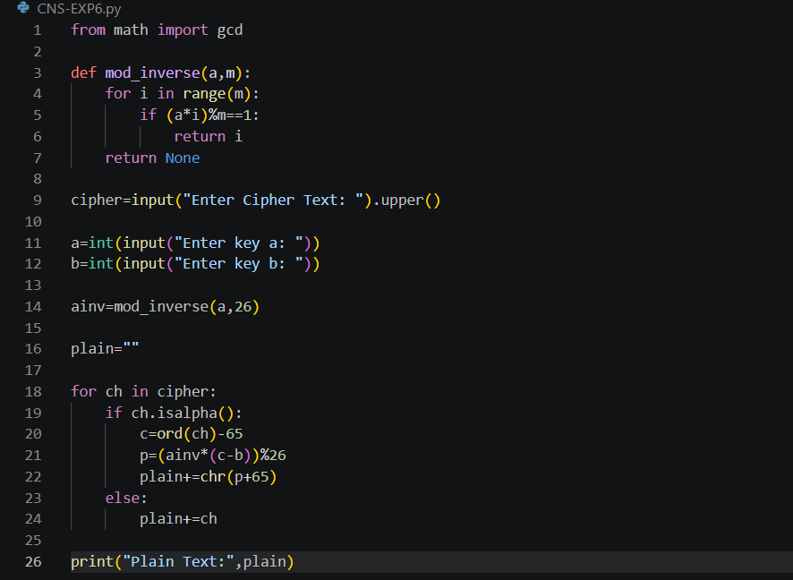

Output:
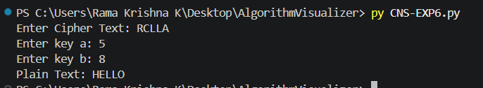

Result:
The Affine Cipher was successfully decrypted using the inverse key.

